PODS ALLOCATION ON THE NODE IN KUBERNETES CLUSTERS  
  
Step 1: pods are allocated based on the cpu utilization on the node.  
 \* if node having 4 vcpus and that was used by the 25 pods your node is fully packed.  
By default no.of pods on the node is 110 but based on the cpu utilization only those pods are allocated.

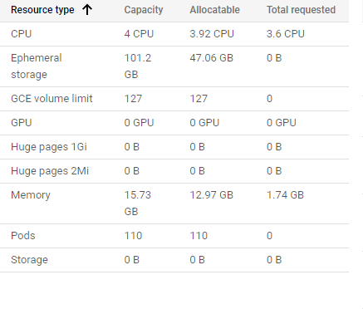  
  
  
Capacity of the node is specified while creating the node and assign the machine type (we can use the custom also based on the requirements we can increase the Vcpu’s.